**IHE Work Item Proposal (Detailed)**

# **1.** **Proposed Work Item: Cardiology Consult and Pathology Board – Workflow Definition**

Proposal Editor:

● Claudio Saccavini, Elena Vio (evio@consorzioarsneal.it), Glauco Brandolino (gbrandolino@consorzioarsenal.it), Mauro Zanardini (mzanardini@consorzioarsenal.it) from Consorzio Arsenàl.IT (Italy) and IHE Italy;

● Charles Parisot (charles.parisot@med.ge.com), Harry Solomon (Harry.Solomon@med.ge.com)

Work item Editor: Mauro Zanardini, Elena Vio, Glauco Brandolino

Date: 3th November 2015

Version: 1.0

Domain: Cardiology, PCC

**Summary**

It is difficult to manage and coordinate remote interaction among healthcare professionals involved in a multidisciplinary and dynamic team on cardiac diseases (Heart Team) that they support peripheral hospitals. A specific workflow in this context that describe what each professionals have to do is missing.

XDS and XSUB profiles define a document sharing infrastructure that support the sharing of documents and the notification but is not enough to create the workflow management infrastructure. XDW profile supports it, but not in this specific field.

The aim of this proposal is to define a standardized workflow document for manage the Heart Team, identifying tasks, tasks relationships, participants involved and rules in the specific workflow, on base of XDW, XDS and XDSUB profiles. XDW profile relies on well-established sharing infrastructures (XDS.b, XDR, XCA), and this allows the XDW workflow management infrastructure to take advantage from the whole set of profile identified to empower/support the document sharing itself (Security, Privacy, Auditing, Notification).

This solution can be applied in many cardiological information systems (CIS), that are in operation worldwide.

The intent of the present proposal is to add a profile that provide add-value to the existing XDS infrastructure for the sharing of cardiological documents, for workflow management (XDW). The problem is a clear example of necessary interoperability among existing systems in cardiological field.

# **2.** **The Problem**

In many countries, the high healthcare specialization is centralized in order to make available widely health resources limited, because they are often very expensive. For this reason, the hub and spoke model between peripheral hospitals and highly specialized hospitals is expanding. This is the case of cardiac surgery. In order to guarantee an optimal treatment strategy in specific field such as stable CAD (Coronary Artery Disease), NSTEMI (non-ST elevation myocardial infarction), Cardiogenic Shock (CS), or aortic valve disease, Italy is moving to overcome hub and spoke model through the creation of teams of professionals able to perform a complete analysis of the more complex clinical cases, thank to a network of hub. This team is called **“Heart Team” (HT)** (Figure 1) and they are responsible for the management of the clinical pathway for patients with cardiac disease (figure 2). The HT includes at least a cardiologist and the closer cardiac surgeon, that may belong to different enterprises or structures. Actually the use of informal consultations via phone, mail or email between cardiologists and cardiac surgeon is the most frequent approach adopted.

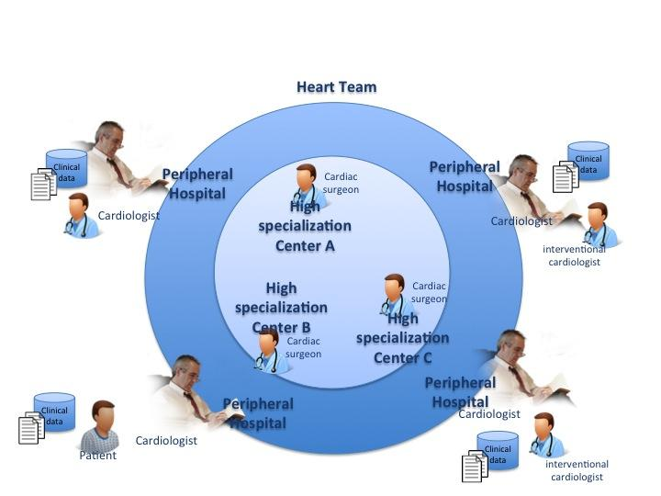

**Figure 1 Heart Team**

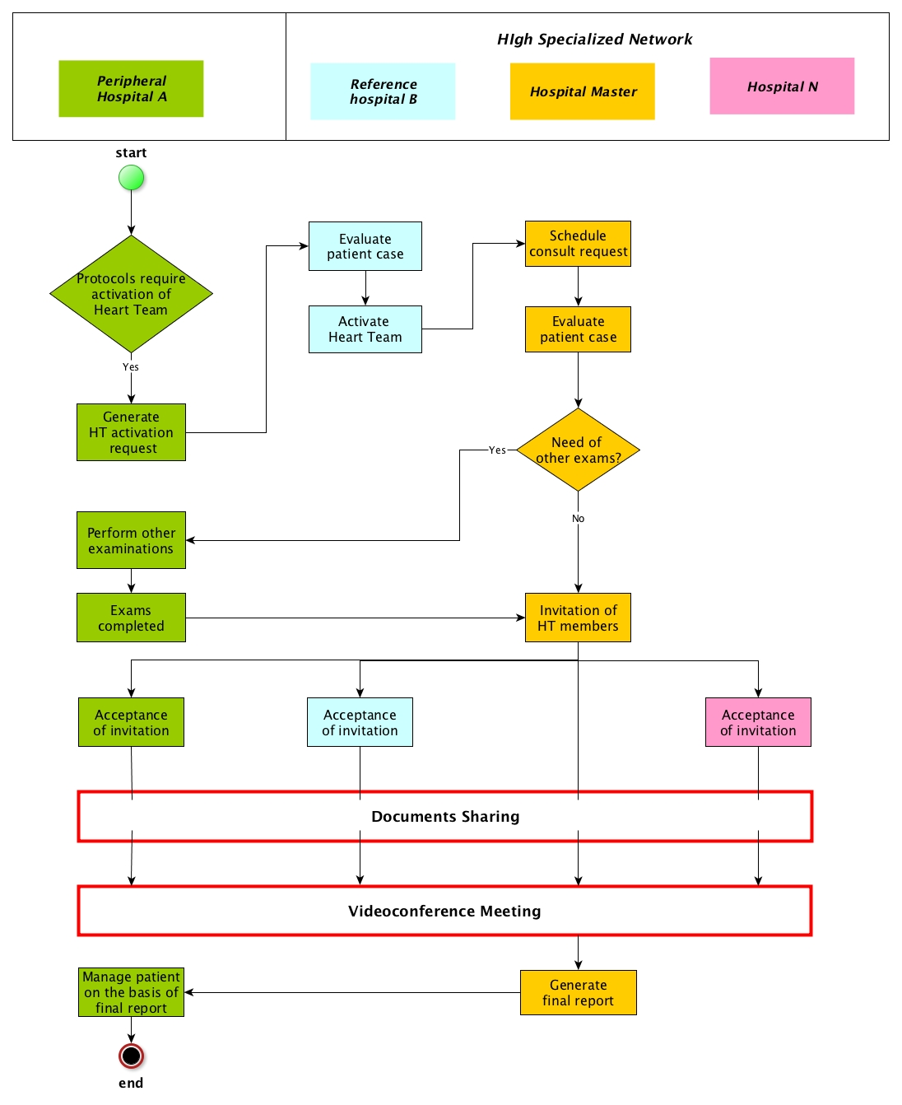

**Figure 2 Typical clinical pathway**

The management of the HT is not simple. The two units (cath lab and/or cardiological ambulatory and cardiac surgery department) may be remote, being sometimes in different geographical areas. Moreover, in many cases, in order to resolve the patient case, the heart team have to be extended, allowing the involvement of more different highly specialized centers with specific skills, belonged to different structures. In fact, a region can have highly specialized centers skilled in specific diseases, creating a network of hubs geographically distributed. For this reason, management of patient data may be difficult and time consuming. In this respect, health information systems which manage clinical records allowing interchange of structured data and images as well as cineloops may provide a significant improvement in overall patient management.

For these reasons, the aim of this proposal is to define a standardized workflow to manage and coordinate remote interaction between HT composed by network of hubs with high specialization on cardiac diseases and peripheral hospitals, with not only a simple sharing of information and digital documents, but also the activation of a multidisciplinary and dynamic team of healthcare professionals. The workflow will support and manage the activation of the dynamic HT that allows us to adapt the team to simple or complex cases.

This approach will enable:

● direct/dynamic enrolment of clinicians in a HT: clinicians are involved in process in relation of their skills and availabilities so that they can be activated promptly;

● Definition of a clear process for the highly specialized center to address heart team activation request: on the basis of the heart team activation request, the guidelines of the process identifies specific physicians of the HT to activate, the time of the response, which patient’s clinical exams have to be exchange, how to reach an agreement between HT members and which data should be reported to the requester.

● Standardization of the HT decisional process: specific documents have to be provide to HT, specific activities have to be carried out on the basis base of case of patient;

● Interaction/relationship with other clinical workflows related: workflow in HT can required input that are the final result of other workflows or triggers other activities managed from other workflows, for example reports produced a result from Referral Workflow, device’s data from Monitoring Workflow, etc.

**Impact**

The profile can be applied on a growing number of patients with cardiac problems. On the world, 3.8 millions of man and 3.4 millions of female die for coronary heart disease each year [1]. CAD is the most common type of heart disease and in 2008, 405,309 individuals died in the U.S. from this specific etiology. Every year, approximately 785,000 Americans suffer a first heart attack and another 470,000 will suffer an additional myocardial infarction (MI). In 2010, CAD alone was projected to cost the U.S. $108.9 billion including the cost of health care services, medications, and lost productivity [2].

In particular, Cardiogenic shock is still an important complication in 5-8% of patients presenting with ST elevation myocardial infarction [3][4] and 2.5% of those with non ST elevation myocardial infarction [5]. This represents around 40.000 to 50.000 patients every year in the United States [6]. Cardiogenic shock is the leading cause of death in patients hospitalized with acute myocardial infarction (AMI) [7,8]. The historic mortality rate for CS complicating an acute myocardial infarction (MI) was 80 to 90 percent [9]. However, lower values for in-hospital mortality have been noted in more studies, ranging from 48 to 74 percent [4, 7-8, 10-12]. Studies have suggested short-term mortality rates between 42 and 48 percent [4,9,13].

Patients presenting CS secondary to MI will generally receive multidisciplinary care [14]. Coronary angioplasty is the reference treatment. Cardiac surgery is an integral part of the treatment of post-MI CS, through emergency bypass surgery, treatment of mechanical complications, or possible implantation of cardiac assistance devices. It is therefore desirable to transfer patients with post-MI CS or with MI plus predictors of secondary CS to an expert center, ideally one that offers interventional cardiology, cardiac surgery with the possibility of cardiac support, and even heart transplantation. If the distance is too great (>2 h between the first contact and artery clearing), patients with post-MI CS or with MI plus signs of CS should be transferred to an interventional cardiology department without cardiac surgery that works in network with an expert center, so as to plan any secondary transport needed after emergency angioplasty.

1.WHO, the global burden of disease: 2004 update

2.<http://www.clevelandclinicmeded.com/medicalpubs/diseasemanagement/cardiology/coronary-artery-disease/Default.htm>

3. Fox KA, Anderson FA, Dabbous OH, Steg PG, López-Sendón J, Van de Werf F et al. (2007).

"Intervention in acute coronary syndromes: do patients undergo intervention on the basis of their risk characteristics? The Global Registry of Acute Coronary Events (GRACE).". Heart 93 (2): 177-82. doi:10.1136/hrt.2005.084830. PMID 16757543.

4. Babaev A, Frederick PD, Pasta DJ, Every N, Sichrovsky T, Hochman JS et al. (2005). "Trends in management and outcomes of patients with acute myocardial infarction complicated by cardiogenic shock.". JAMA 294 (4): 448-54. doi:10.1001/jama.294.4.448. PMID 16046651.

5. Hasdai D, Harrington RA, Hochman JS, Califf RM, Battler A, Box JW et al. (2000). "Platelet glycoprotein IIb/IIIa blockade and outcome of cardiogenic shock complicating acute coronary syndromes without persistent ST-segment elevation.". J Am Coll Cardiol 36 (3): 685-92. PMID 10987585.

6. Thom T, Haase N, Rosamond W, Howard VJ, Rumsfeld J, Manolio T et al. (2006). "Heart disease and stroke statistics--2006 update: a report from the American Heart Association Statistics Committee and Stroke Statistics Subcommittee.". Circulation 113 (6): e85-151. doi:10.1161/CIRCULATIONAHA.105.171600. PMID 16407573.

7. Goldberg RJ, Samad NA, Yarzebski J, Gurwitz J, Bigelow C, Gore JM. Temporal trends in cardiogenic shock complicating acute myocardial infarction. N Engl J Med. 1999;340:1162–1168.

8. Goldberg RJ, Gore JM, Thompson CA, Gurwitz JH. Recent magnitude of and temporal trends (1994–1997) in the incidence and hospital death rates of cardiogenic shock complicating acute myocardial infarction: the second national registry of myocardial infarction. Am Heart J. 2001;141:65–72.

9. Goldberg RJ, Spencer FA, Gore JM, et al. Thirty-year trends (1975 to 2005) in the magnitude of, management of, and hospital death rates associated with cardiogenic shock in patients with acute myocardial infarction: a population-based perspective. Circulation 2009; 119:1211.

10. Hochman JS, Boland J, Sleeper LA, et al. Current spectrum of cardiogenic shock and effect of early revascularization on mortality. Results of an International Registry. SHOCK Registry Investigators. Circulation 1995; 91:873.

11.Holmes DR Jr, Bates ER, Kleiman NS, et al. Contemporary reperfusion therapy for cardiogenic shock: the GUSTO-I trial experience. The GUSTO-I Investigators. Global Utilization of Streptokinase and Tissue Plasminogen Activator for Occluded Coronary Arteries. J Am Coll Cardiol 1995; 26:668.

12.Holmes DR Jr, Berger PB, Hochman JS, et al. Cardiogenic shock in patients with acute ischemic syndromes with and without ST-segment elevation. Circulation 1999; 100:2067.

13. TRIUMPH Investigators, Alexander JH, Reynolds HR, et al. Effect of tilarginine acetate in patients with acute myocardial infarction and cardiogenic shock: the TRIUMPH randomized controlled trial. JAMA 2007; 297:1657.

14. Levy B, Bastien O, Benjelid K, Cariou A, Chouihed T, Combes A, Mebazaa A, Megarbane B, Plaisance P, Ouattara A, Splaulding C, Teboul JL, Vanhuyse F, Boulain T, Kuteifan K. Experts’ recommendations for the management of adult patients with cardiogenic shock. Ann Intensive Care. 2015;5(1):17. doi: 10.1186/s13613-015-0052-1.

# **3.** **Use Cases**

Two use cases are described in this proposal. The first use case covers a simple management of interaction between interventional cardiologist belong to peripheral hospital and cardiac surgeon belong to highly specialized central (a basic Hearth Team) in order to provide a support in the taken decision on intervention for the patient. The second use case covers a complex management of interaction among professionals involved in an extensive Health Team.

**Use case 1: Activation and operating principles of the Heart Team with an IT infrastructure in simple case**

The following Use Case illustrates the Workflow for the activation of the Heart Team (HT) and how it works with the application of proposed profile.

Health structure involved:

A: Peripheral hospital (HA) with a cardiac department including cathlab authorized to perform PCI

B: Health Hospital (HB) with a cardiac surgery department not authorized to heart transplant and implants of all types of mechanical cardiac support (the heart surgery referral for HA)

1. Patient case

Dr. Ralph, an interventional cardiologist in hospital A (HA), visits a 67-year-old male patient with hypertension and without a previous history of cardiac disease started complaining of effort angina, CCS class III. The patient undergone to a cardiac echocardiogram to evaluate the heart functionality. The systolic function of the left ventricle was normal, with an ejection fraction of 60%. Dr. Smith decide to evaluate the patient with a coronary angiography the same week, revealing critical (90%) stenosis at the ostium of the left anterior descending (LAD) and left circumflex (LCX) coronary arteries, and diffuse disease of the right coronary artery (RCA). SYNTAX score is 20.

Patients with a multi-vessels stenosis and with SYNTAX score ≤22 shall be discussed in a weekly HT (http://www.ncbi.nlm.nih.gov/pubmed/23166211).

2. Request

Dr. Ralph proceeds to send the request for the activation of the Heart Team to closer cardiac surgeon, Dr. Johnson (Hospital B - HB), as process requires. The activation request links the following documents: Medical history, Drug therapy, Biochemical profile test blood, Euroscore II and Syntax score, ECG (Image), Angiography and ventriculography (Cine-loops).

3. Request Notification

Dr. Johnson is notified for request of activation of HT.

4. Activation HT

Dr. Johnson retrieves documents and reviews the case. He decides that is better to involve Dr. Ralph in the HT in order to decide the appropriate intervention for patient.

5. HT Notification

Dr. Ralph is notified for the involvement in HT because Dr. Johnson needs to discuss the case with him, before to decide the treatment.

6. HT Perform

Dr. Johnson realizes that he needs results of Echo-cardiogram (Cine-loops) and requires it to Dr. Ralph. When the result is available, it is notified to HT members. Dr. Johnson informs Dr. Ralph to attend to a virtually meeting next monday at 10.00.

5.1 HT virtual meeting

The professionals involved to HT meet each other in a videoconference. The HT analyzes the clinical case and the actually clinical patient status to achieve the optimal choice for the patient’s treatment.

The taken decision is a CABG intervention.

5.2 Management of the patient between the HS involved

Dr. Johnson sends to Dr. Ralph the preliminary report with the decision taken.

6. Final Report

To perform this strategy, Dr Johnson requires other examinations: Hemogasanalysis and Eco-color doppler (Cine-loops). When results are available, Dr. Johnson finalized the final report.

**Use case 2: Activation and operating principles of the Heart Team with an IT infrastructure in emergency and complex HT**

The following Use Case illustrates the Workflow for the activation of the Heart Team (HT) and how it works with the application of proposed profile.

Health structure involved:

A: Peripheral hospital (HA) with a cardiac department including cathlab authorized to perform PCI and to implant a IABP (Intra-Aortic Balloon Pump)

B: Health Hospital (HB) with a cardiac surgery department not authorized to heart transplant and implants of all types of mechanical cardiac support (the heart surgery referral for HA)

C. Health Hospital (HC) with a cardiac surgery department authorized to heart transplant and implants of all types of mechanical cardiac support (The specialized heart surgery referral for HB)

1. Patient case

A hospitalized patient, in HA, with advanced heart failure experiments a cardiogenic shock. DR. Smith, a clinical cardiologist in Hospital A (HA), immediately visits the patient and from the ECG evaluation diagnoses a myocardial infarction. He immediately starts the optimal pharmacological therapy (inotropes and vasopressors) to stabilize the clinical patient status and he advises the interventional cardiologist (Dr. Ralph in HA) to perform a PCI (percutaneous coronary intervention).

2. Request

Dr. Smith proceeds to send the request for the activation of the Heart Team, as the protocol for cardiogenic shock requires, to closer cardiac surgeon, Dr. Johnson belong to Hospital B (HB). Dr. Smith sends the request for the activation and creation of the HT to the HB. The activation request links the following documents: Medical history, Drug therapy, Biochemical profile test blood, ECG (Image), Chest radiography (Image), Echo-cardiogram (Cine-loops), Hemogasanalysis, Eco-color doppler (Cine-loops), Neurological status evaluation or cerebral CT (Images).

3. Request Notification

Dr. Johnson is notified for request of activation of HT.

4. Activation HT

Dr. Johnson reviews the case and decides who is better to involve in the HT in order to decide the appropriate treatment of patient. In his CIS, he selects professionals to be involved in HT:

- Himself as the owner of the HT process, Dr. Johnson

- the interventional cardiologist of HA, Dr. Raph,

- the clinical cardiologist of HA , Dr. Smith,

- the cardiac surgery physician of the HC, Dr. House, because the implant of a LVAD (Left ventricular assessment device) could be a strategy.

In this way, a dynamic HT is defined.

5. HT Notification

The whole HT is notified for the involvement on the basis of the process workflow. The involved professionals can view all documents shared in this case: the request and clinical documents of the patient case. The case is urgent, therefore he informs all members that the patient case will be discussed as soon as the PCI procedure will be finalized.

6. HT Perform

When the PCI was successfully concluded, Dr. Ralph notifies all members on the end of the procedure linking the final angiography performed and new clinical patient parameters.

The patient recovers the heart pump functionality but not enough. The HT owner (Dr. Johnson) refers to Dr. Ralph to insert an IABP to stabilize patient and informs all members of the HT to attend a virtually meeting after 2 hours.

5.1 HT virtual meeting

The professionals invited to HT meet each other in a videoconference. The HT analyzes the clinical case and the actually clinical patient status to achieve the optimal choice for the patient’s treatment.

The final decision strategy is to assist the patient with an ECMO (Extracorporeal membrane oxygenation) device as a bridge to recovery the heart pump functionality. They consider that the ECMO is a sufficient device to stabilize clinical patient status with good chance of heart recovery and a next discharge of the patient. So the implant of the ECMO will be performed in HB. To perform this strategy other exams are requested.

5.2 Management of the patient between the HS involved

Dr. Johnson sends to the HT members a preliminary report with the decision taken.

6. Final Report

To finally perform this strategy before his team will arrive to implant the ECMO and carry out the patient to HB, Dr Johnson requires other examination: whole-body CT angiography (Cine-loops). When results are available, Dr. Johnson finalized the final report.

# **4.** **Standards & Systems**

Systems that can be involved in the process described above are:

● CIS system

● Hospital EHR system

● HIS

The relying standards that can be adopted to address the use case are:

* XDS.b-I (Cross-Enterprise Document Sharing) for Imaging, XDS.b (Cross-Enterprise Document Sharing)
* DSUB (Document Metadata Subscription): this profile allows to create a notification infrastructure based the XDS.b Infrastructure
* XDW (Cross-Enterprise Document Workflow): this profile allows the creation of a Workflow management Infrastructure based on a XDS.b Environment. XDW guidelines provide a flexible tool that can be further profiled (defining a Workflow Definition profile) to manage specific clinical workflows.

# **5.** **Technical Approach**

**New actors**

* HT Requester: actor that requires the activation of HT for a clinical support
* HT Performer: actor that manages the HT and concludes it with a final report and exams for the operation
* HT Participant: actor that participates to the HT

**Existing actors**

See XDW, XDS.b, XDS.b-I and DSUB

**New transactions (standards used)**

None

**Impact on existing integration profiles**

None

**New integration profiles needed**

The proposed profile aim to define a Workflow definition for Cardiology. This content profile captures, in a document, the Heart Team Workflow definition for management of interaction between units of peripheral hospital and highly specialized hospitals with cardiac surgery and among highly specialized hospitals with cardiac surgery. The document is intended for use by the XDW Cross-Enterprise Document Workflow profile.

This profile will be the first Workflow Definition based on XDW that will provide a structured format for the workflow definition itself. This will be based on “Workflow Definition BPMN” guidelines (a White Paper drafted by the IHE PCC Domain). Such a structured representation supports automation of several important efforts, including:

· Generation of workflow documentation from the structured definition,

· Construction of conformance requirements for workflow participants,

· Development of test tools and simulators,

· Implementation of and integration with workflow participants.

**Technical Details for an XDW Workflow Definition Profile**

**1.** **Sharing Infrastructure**

A Workflow Definition Profile based on XDW, is a profile that identifies Tasks, Tasks Relationships and Participants involved in a specific workflow. XDW defines a multi-purpose tool (the Workflow Document) that enables Workflow Definition profile authors to specify additional rules applicable to specific workflows. General rules about the management/sharing of the Workflow Document itself are inherited by the XDW profile.

XDW profile relies on well-established sharing infrastructures (XDS.b, XDR, XCA), and this allows the XDW workflow management infrastructure to take advantage from the whole set of profile identified to empower/support the document sharing itself (Security, Privacy, Auditing, Notification).

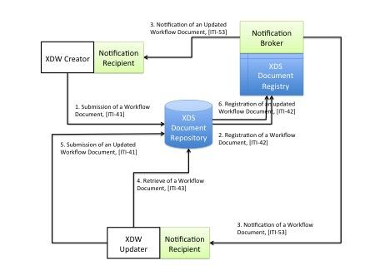

Figure 3: XDW with a XDS/DSUB infrastructure

DSUB profile provides a Notification Infrastructure that allows triggering notifications when a new document, characterized by specific metadata, is published. Workflow Participants can subscribe their participation to a specific instance of workflow, or they can be notified for any workflow document published that meets specific requirements.

This approach simplifies the Actor requirements of workflow participant: those systems are required just to consume the content of a Workflow Document and update it in accordance to the workflow definition rules.

**2.** **Task Definition**

In this section we will briefly describe main tasks identified by the HT workflow. XDW profile is an integration profile that allows to describe tasks across the border of enterprises, so it is of scope for this Workflow Definition profile, the description of internal processes that allows to accomplish a task within an enterprise itself.

* TASK 1 - Request: this task allows a HT request actor to request the activation of an HT in order to discuss the clinical case.
  + Required task performed by the HT request actor.
  + INPUT: Clinical reports and imaging.
  + OUTPUT: Request Document
  + Allowed taskStatus:
    - COMPLETED: this task born completed.
* TASK 2 - Perform: this task allows a HT Performer actor to obtain the final decision for the treatment of the patient.
  + Required task performed by the HT Performer actor.
  + INPUT: Clinical reports, imaging and Request document provided via REQUEST task.
  + OUTPUT: a Preliminary Report, optionally other workflow document (es. eReferral)
  + Allowed taskStatus:
    - CREATED: this task is added in this status when the Request task is completed.
    - RESERVED: this task is added in this status when the owner of this task changes owner because the surgeon supposes this task have to manage by another surgeon.
    - IN PROGRESS: this task is added in this status when the HT Performer:
      * takes in charge the process.
      * creates new tasks HT involvement
      * links other workflow document (i.e. eReferral)
    - COMPLETED: this task is turned into status COMPLETED when the Preliminary Report is created.
    - FAILED: this task can turn into a failed status if the HT Performer actor cannot performed the task, for example when the patient dies.
* TASK 3 - HT Involvement: this task allows a HT Participant actor to participate to the HT in order to provide his expertise focused on the case.
  + Optional task performed by the HT Participant actor. One task for each involved participant.
  + INPUT: Clinical reports, imaging and Request document provided via REQUEST task.
  + OUTPUT: optionally a preliminary evaluation
  + Allowed taskStatus:
    - CREATED: this task is added in this status when the owner of HT Perform task invites other professionals in HT.
    - IN PROGRESS: this task is added in this status when the HT Participant take in charge the process.
    - COMPLETED: his task is turned into status COMPLETED when the Preliminary evaluation is created or videoconference is concluded.
* TASK 4 - Finalization: this task allows a HT Performer actor to finalized the response and to complete with exame useful for surgery.
  + Required task performed by the HT Performer actor.
  + INPUT: a Preliminary report provided via PERFORM task.
  + OUTPUT: a Final Report and optionally other Workflow documents (i.e. eReferral) and Clinical reports for surgery
  + Allowed taskStatus:
    - CREATED: this task is added in this status when the owner of HT Perform have completed PERFORM task..
    - IN PROGRESS: this task is added in this status when the HT Performer:
      * take in charge the process
      * links other workflow document (i.e. eReferral).
    - COMPLETED: this task is turned into status COMPLETED when the Final Report and Clinical reports for surgery are created.
    - FAILED: this task can turn into a failed status if the HT Performer actor cannot performed the task, for example when the patient dies.

**Breakdown of tasks that need to be accomplished**

It would be useful to engage the collaboration between Cardiology and PCC, sharing experience with XDW workflow definitions (PCC domain) and cardiological context (Cardiology domain). Cardiology Domain could work on Volume 1, and PCC could contribute heavily to the creation of Volume 2 and Volume 3 of the proposed profile.

# **6.** **Risks**

The risks are related to a possible lack of leadership among PCC and cardiology

# **7.** **Open Issues**

Decision on collaboration between Cardiology and PCC.

# **8.** **Effort Estimates**

Cardiology Domain could work on Volume 1 on the definition of specific use case for cardiological field, and PCC could contribute heavily to the creation of Volume 2 and Volume 3 of the proposed profile.